presents
Ugo Tognazzi: A Film Series
Saturday, April 27, 2019
Castro Theatre
429 Castro Street, San Francisco, CA 94114
In collaboration with
The Italian Cultural Institute and the Consul General of Italy in San Francisco
Organized by Cinema Italia San Francisco
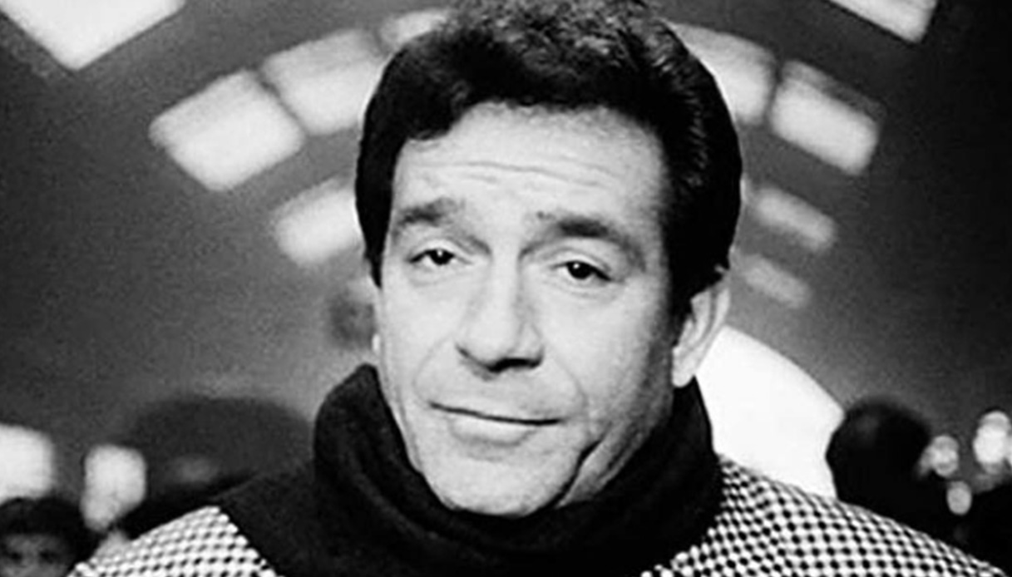

For our 9th program at the Castro Theatre, we are proud to present Italian icon Ugo Tognazzi. As an actor, director and screenwriter, Tognazzi performed in over 150 films in the Golden Age of Italian Cinema. Together with Vittorio Gassman, Marcello Mastroianni, Alberto Sordi and Nino Manfredi, Ugo Tognazzi invented and popularized the commedia all'italiana, a genre mixing comedy and melancholy, that swept the box office in Italy from 1960 to 1970.
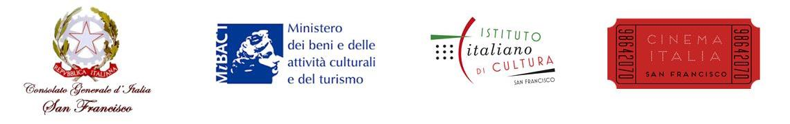

Saturday, April 27 - Full Schedule
10:00 AM Elio Petri’s Property is No Longer a Theft (1973), 127 min, Cinecittà 35 mm,
Titanus
12:45 PM Bernardo Bertolucci’s Tragedy of a Ridiculous Man (1981), 116 min, Cinecittà
35 mm, Warner Bros
3:30 PM Dino Risi’s In the Name of the Italian People (1971), 102 min, Cinecittà 35 mm,
Rialto
6:30 PM Édouard Molinaro’s La Cage aux folles (1978), 97 min, DCP, Park Circus
8:30-10 PM The Big Feast Party
10:00 PM Marco Ferreri’s La Grande Bouffe (1973), 129 min, Cinecittà 35 mm,
Drafthouse.
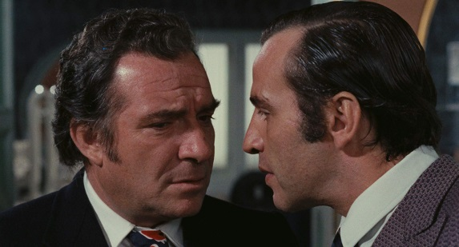
Property is No Longer a Theft
La proprietà non è più un furto
Directed by Elio Petri
Screenplay by Elio Petri, Ugo Pirro
With Ugo Tognazzi, Flavio Bucci, Daria Nicolodi.
In Italian with English subtitles
Italy, 1973, 127 min.
In the early 1970s, the revolutionary Red Brigade waged its terrifying campaign to bring down Italy through kidnappings, murders, and bank robberies. Elio Petri made this proto-giallo, Brechtian satire about a neurotic bank clerk (Flavio Bucci) who commits to a Marxist life of thievery, choosing as his principal target a client known as The Butcher (Ugo Tognazzi).
Archival 35 mm film print from Luce Cinecittà. Courtesy of Titanus.
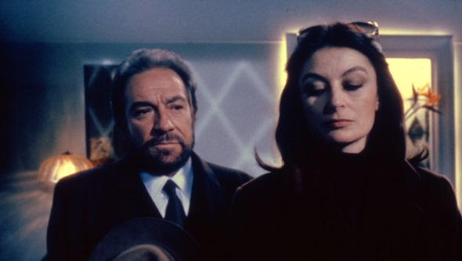
Tragedy of a Ridiculous Man
La tragedia di un uomo ridicolo
Directed and written by Bernardo Bertolucci
With Ugo Tognazzi, Anouk Aimée, Laura Morante.
In Italian with English subtitles.
Italy, 1981, 116 min.
Tognazzi gives the performance of his career as the impotent, “ridiculous” man in Bertolucci’s extraordinary late-period film, about the anguished relationship between a failing industrialist and his son, who is kidnapped by left-wing terrorists under mysterious circumstances.
Archival 35 mm film print from Luce Cinecittà. Courtesy of Warner Bros.
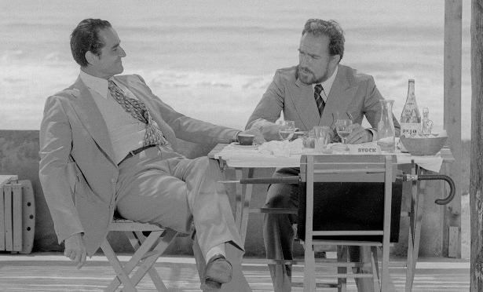
In the Name of the Italian People
In nome del popolo italiano
Directed by Dino Risi
Screenplay by Agenore Incrocci Furio Scarpelli
With Ugo Tognazzi, Vittorio Gassman, Ely Galleani.
In Italian with English subtitles.
Italy, 1971, 102 min.
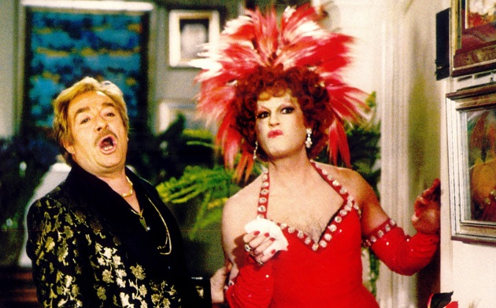
Set in early 1970s Rome, a city of rotting garbage and moral decay, this rarely screened piece of political buffoonery stars Vittorio Gassman as a vainglorious industrialist who would sooner commit his father to an insane asylum than face charges in the murder of a young girl. His foil, played by Ugo Tognazzi, is the cynically bemused magistrate bent on holding him accountable not only for this sordid crime, but for the venal sins of an entire populace.
Archival 35 mm film print from Luce Cinecittà. Courtesy of Rialto Pictures.
La Cage aux Folles
Birds of a Feather
Directed by Édouard Molinaro
Screenplay by Jean Poiret, Francis Veber, Édouard Molinaro, Marcello Danon.
With Ugo Tognazzi, Michel Serrault, Claire Maurier.
France/Italy, 1978, 97 min.
In Italian with English subtitles.
An international blockbuster that begat two sequels and a Tony Award-winning Broadway musical, La Cage was adapted from Jean Poiret’s warm-and-winning stage farce about a pair of aging queens—Renato, owner of a scandalous St. Tropez nightclub (Tognazzi), and Albin (Serrault), his transvestite “roommate”—who, through a series of exquisitely timed comic set pieces, attempt to conceal their gay “lifestyle” from the ultraconservative soon-to-be in-laws of Renato’s son.
DCP print. Courtesy of Park Circus.
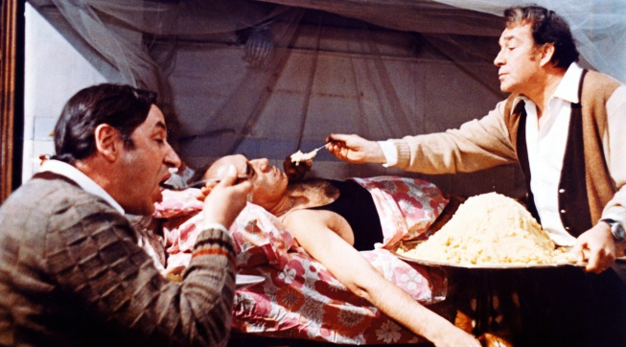
La Grande Bouffe
The Big Feast
Directed and written by Marco Ferreri
With Ugo Tognazzi, Marcello Mastroianni, Michel Piccoli.
In French with English subtitles.
France/Italy, 1973, 129 min.
A pilot (Mastroianni), a cook (Tognazzi), a TV star (Piccoli) and a judge decide to gorge themselves to death on fine cuisine. Ferreri’s notorious orgy of Rabelaisian appetites brings together some of Europe’s greatest actors for a defiantly scatological Last Supper.
Archival 35 mm film print from Luce Cinecittà. Courtesy of Drafthouse.

Tickets
- Screenings: $13.00 per admission
- La Cage aux Folles screening: $15.00 per admission
- Party: $25.00 per admission
- Festival Pass (all films + party): $70.00 per pass
Online ticket sales begin on March 4, 2019 via CinemaItaliaSF.com
Free Special Event
Thursday, April 25, 6:30 pm at the Italian Cultural Institute: Screening of the documentary Ritratto di mio padre (Portrait of my Father) (2010), 87 min. DVD courtesy of Surf.
Directed by Maria Sole Tognazzi. Limited seating. RSVP Required
For more information about this event, please visit www.iicsanfrancisco.esteri.it/
Presenting Organizations
Established in May 2010, following the merger of Cinecittà Holding and Istituto Luce (founded in 1924), Istituto Luce Cinecittà is the public service branch of the Italian Ministry of Cultural Heritage and Activities and Tourism with the aim of promoting classic and contemporary Italian cinema worldwide, through traveling programs in major international institutions. Such programs include: film retrospectives of Italy’s most prominent directors and actors, art and photographic exhibitions, books presentations, support in the selection of Italian films at film festivals, and the participation of Italian talents attending international events. www.cinecitta.com
The Italian Cultural Institute of San Francisco promotes Italian language, culture, and the best of Italy by offering information about Italy, scholarships, and cultural events, such as: art exhibits, film screenings, concerts, and lectures. The Institute’s goal is to foster mutual understanding and cultural cooperation between Italy and the United States. www.iicsanfrancisco.esteri.it
Cinema Italia San Francisco, founded in 2013, is an organization that operates in San Francisco bringing to major screens the best of Italian Cinema. This will be the 9th program organized by CISF in the Bay Area: Pasolini (2013), Bertolucci (2014), De Sica (2015), Magnani (2016), Dino Risi and Lina Wertmüller (2017), Michelangelo Antonioni and Marcello Mastroianni (2018).
Cinema Italia San Francisco is a member of Intersection for the Arts, which provides fiscal sponsorship, incubation and consulting to artists. www.theintersection.org
CinemaItaliaSF.com
Facebook/Twitter/Instagram @CinemaItaliaSF #CinemaItaliaSF

